

**ENERGY AUDIT CONDITIONAL GRANT REPORT**

FOR

**Building Name**

Prepared by

|  |  |
| --- | --- |
| Company logo  Image with solid fill | Client logo  Image with solid fill |
| Auditor Name and Address | Client Name and Address |

Under

**SUSTAINABLE ENERGY DEVELOPMENT AUTHORITY MALAYSIA**

CONFIDENTIALITY

This document contains information for the sole perusal of *Client name* located in *Client address*. All information contained here is prohibited from being copied out. The information here shall not be copied, printed or disclosed to any 3rd party sources without prior written permission from *Client name*.

DISCLAIMER

*Auditor Name* located in *Auditor address* has no personal or financial interest in supplying or installing equipment for this document.

**Table of Contents**

GLOSSARY 5

1 EXECUTIVE SUMMARY 6

2 INTRODUCTION 8

2.1 OBJECTIVE 8

2.2 METHODOLOGY 9

2.3 TYPE OF ENERGY AUDIT AND PROCESS 9

2.4 SCOPE OF WORK 9

2.5 TIME SCHEDULE AND AUDIT FRAMEWORK 9

2.6 ENERGY AUDIT EQUIPMENT 9

3 MANAGEMENT OF ENERGY 11

3.1 POLICY AND TARGETS 11

3.2 ENERGY DATA, DOCUMENTATION AND MONITORING 11

3.3 COMPLIANCE TOWARDS REGULATIONS 12

3.4 ENERGY MANAGEMENT TEAM 12

3.5 ENERGY AUDIT TEAM 12

3.6 ENERGY MANAGEMENT MATRIX REVIEW 13

3.7 OPERATIONS AND MAINTENANCE SYSTEM REVIEW 14

4 BUILDING DESCRIPTION 15

4.1 BUILDING ORIENTATION AND FOOTPRINT 15

4.2 BUILDING ENVELOPE 16

4.2.1 Window 16

4.2.2 Wall Structure 16

4.2.3 Roof Structure 16

4.2.4 OTTV/RTTV 17

4.3 DAYLIGHTING 18

4.4 NATURAL VENTILATION 18

4.5 CEILING (HEIGHT) AND FLOOR – MATERIAL AND COLOUR 18

4.6 LANDSCAPING 18

5 ELECTRICAL SUPPLY INFORMATION AND ANALYSIS 19

5.1 TARIFF REVIEW 19

5.2 MAXIMUM DEMAND REVIEW 19

5.3 VOLTAGE LEVEL 19

5.4 HISTORICAL ENERGY CONSUMPTION 19

5.5 POWER FACTOR 20

6 ENERGY CONSUMPTION INFORMATION AND ANALYSIS 23

6.1 ELECTRICITY SUPPLY 23

6.1.1 SYSTEM DESCRIPTION 23

6.1.2 BUILDING LOAD PROFILE ANALYSIS 23

6.1.3 OBSERVATION AND FINDINGS 24

6.2 CHILLED WATER SYSTEM AND DISTRIBUTION 24

6.2.1 SYSTEM DESCRIPTION 24

6.2.2 LOAD PROFILE ANALYSIS 25

6.2.3 OBSERVATION AND FINDINGS 26

6.3 AIR CONDITIONING AND MECHANICAL VENTILATION SYSTEM 27

6.3.1 SYSTEM DESCRIPTION 27

6.3.2 BLOWER FAN SPECIFIC POWER 28

6.3.3 AIR CHANGE RATE AND AHU CAPACITY ANALYSIS 28

6.3.4 INDOOR AIR QUALITY 28

6.3.5 TEMPERATURE AND RELATIVE HUMIDITY 29

6.3.6 OBSERVATION AND FINDINGS 29

6.4 LIGHTING SYSTEM 30

6.4.1 SYSTEM DESCRIPTION 30

6.4.2 LUX LEVEL 31

6.4.3 OBSERVATION AND FINDINGS 31

6.5 VERTICAL TRANSPORT SYSTEM 31

6.5.1 SYSTEM DESCRIPTION 31

6.5.2 LIFT/ESCALATOR USAGE ANALYSIS 32

6.5.3 OBSERVATION AND FINDINGS 32

6.6 PLUG LOADS 32

6.6.1 PLUG LOADS USAGE ANALYSIS 32

6.6.2 OBSERVATION AND FINDINGS 32

6.7 BUILDING MANAGEMENT SYSTEM 32

6.7.1 SYSTEM DESCRIPTION 32

6.7.2 OBSERVATION AND FINDINGS 33

7 LOAD APPORTIONING AND ENERGY INDICES 34

7.1.1 LOAD APPORTIONING 34

7.1.2 ENERGY INDICES 34

8 ENERGY SAVING MEASURES AND FINANCIAL EVALUATION 35

8.1.1 SUMMARY OF ENERGY SAVING MEASURES 36

9 ENERGY SAVING MEASURES IMPLEMENTATION PLAN (3 YEARS) 37

10 CONCLUSION 37

11 VERIFICATION 38

# GLOSSARY

In this report, the following words and abbreviations shall be defined as follows:

|  |  |
| --- | --- |
| **Words/Abbreviations** | **Definition** |
| Audit | Energy Audit |
| TRH | Ton Refrigerant Hour |
| TNB | Tenaga Nasional Berhad |
| kWh | kilowatt hour |
| MD | Maximum Demand |
| PF | Power Factor |
| ESM | Energy Saving Measures |
| BCS | Building Control System |
| DDC | Direct Digital Control |
| BEI | Building Energy Index |
| LEI | Lighting Energy Index  **sample** |
| ACEI | Air Conditioning Energy Index |
| PEI | Plug Load Energy Index |
| OTTV | Overall Thermal Transfer Value |
| RTTV | Roof Thermal Transfer Value |
| WWR | Window to Wall Ratio |
| CCTV | Closed Circuit Television |
| ACMV | Air Conditioning Mechanical Ventilation |
| COP | Coefficient of Performance |
| CHWP | Chilled Water Pump |
| CWP | Condenser Water Pump |
| CT | Cooling Tower |
| HEX | Heat Exchanger |
| AHU | Air Handling Unit |
| FCU | Fan Coil Unit |
| VAV | Variable Air Volume |
| VRV | Variable Refrigerant Volume |
| VSD | Variable Speed Drive |
| EnMS | Energy Management System |
| DPM | Digital Power Meter |
| BCiS | Building Consumption Input System |

# EXECUTIVE SUMMARY

Brief summary of the audit, building, key systems audited, consumption and breakdown of consumption.

*Example*

This report represents the findings of the Energy Audit conducted by Auditor name for Client name, between date. The equipment audited includes the chiller plant, centralised air conditioning system and lighting system. The audit for the general equipment was done using a general survey.

Building name has an estimated total gross building area of **987m2** , net floor are of **869m2** and an air-conditioned area of **733m2**. The annual electricity consumption obtained from the historical TNB billing data for the year 2019 is **232,050kWh** costing **RM66,831**. Building name is a single story building.

Briefly describe the chart.

*Example*

The air-conditioning load for the Building name building comprises of about **76%** of the total building load. The lighting and general equipment comprise **12%** and **4%** respectively of the total building load.

**sample**

Brief summary of energy savings recommendations.

*Example*

Seven (7) Energy Saving Measures (ESMs) have been identified in the Energy Audit conducted. By implementing all recommended Energy Saving Measures, the energy consumption for Building name can be reduced by about **23%**, or **52,416kWh** per year representing **RM15,096** in monetary value. The estimated budget cost of implementing the Energy Saving Measures is **RM27,042** with a payback period of about **1.79 years**. The estimated savings, budget costs and Simple Payback Period of all recommended Energy Saving Measures, are listed in the table below.



**sample**

Brief summary of the existing BEI and the new reduced BEI.

*Example*

Using the estimated current annual energy consumption **232,050kWh** and occupied areas, the current Building Energy Index (BEI) is **274 kWh/m2/year** costing **RM67.68/m2/year** and after implementing all recommended Energy Saving Measures to **163 kWh/m2/year** costing **RM52.13/m2/year.** The percentage reduction is **41%.**

**41% Reduction**

**sample**

Refer diagram below on the number of diamonds achieved based on the percentage reduction in energy consumption



Based on the SEDA Sustainable Energy Low Carbon Building Assessment GreenPASS by Construction Industry Standard 2012 CIS20, the level of achivement in xx % carbon reduction is eligible for xx diamond certification. All the information can get from the SEDA website.

https:/www.seda.gov.my/greenpass

# INTRODUCTION

Brief explanation on functions, operation hours, occupancy rate, etc.

*Example*

Commercial office buildings are the second largest energy consumers in Malaysia amounting to **30%** of the total energy consumed in the country. The building energy consumption is found to be very high from past energy audits conducted on various commercial buildings around the country. Most of it comes mainly from equipment oversizing and extended operation hours when occupancy is very low and poor building operation and control.

The energy audit is a major component of an Energy Management System (EnMS) and has to be carried out continuously to ensure continuous of monitoring, control and management of energy use as well as reduction in energy consumption.

Client name, as part of the maintenance contract has to conduct a detailed energy audit exercise for the building in location. Client name has appointed Auditor name, the energy service company to conduct the energy audit.

Building name was built in 2004 and has been in full operation for the last 22 years. It comprises of two (2) floors consisting of a Ground Floor and 1st Floor. The General Office, Cubicle Office Rooms, Meeting Rooms, Laboratories, Pantry and Café occupy the Ground Floor. The 1st Floor consists of a small area for the Air-conditioning Plant Room, which is next to the Library and another general office area.

With a capacity of 200 occupants, the building serves as the head office for Client name. The building operates from 8.30 am to 5.30 pm daily. Saturday and Sunday are non-working days. In general, the main function of the building is to serve as an office and also as a research centre.

**Building Description**

|  |  |
| --- | --- |
| Building Name: | **Client name** |
| Address: | **Client address** |
| Building Use: | **Commercial Office and Research Centre** |
| In operation since: | **2004** |

## OBJECTIVE

Brief explanation

*Example*

The objective of a detailed energy audit study is to determine the energy performance of the building through detailed measurement and analysis, and identify potential savings that can optimize energy consumption, reduce wastage and reduce the operating costs of the building.

The compiled data and findings from this audit is to be used to assist Client name to monitor and operate the plant more efficiently and at the same time identify potential energy saving measures for improved performance and optimization of equipment operation.

## METHODOLOGY

Brief explanation-As per SEDA Guideline

*Example*

The methodology used for the energy audit is based on SEDA’s guideline shown below. The kick off meeting was held on date/time. All desktop data was made available to the energy audit team prior to the on-site audit works. The on-site audit works was held between date and date. There were some delays due to unforeseen circumstances, but the energy auditor managed to complete all works within the stipulated timeframe.



The data collection and analysis of all data was completed within the timeframe given. The energy baseline was determined from the past year TNB bills analysis and was cross referenced with the 2 week data logging that took place at the beginning of the audit. During the on-site survey and investigation, several weaknesses on energy wastage were identified. These are listed in the energy supply and consumption analysis sections. Recommendations for energy saving opportunities, financial evaluation and projected implementation was completed in the last week before submission of the draft report and are highlighted in the energy saving and financial evaluation, and implementation sections of the report. Refer figure below.



## TYPE OF ENERGY AUDIT AND PROCESS

Brief explanation/As per SEDA Guideline

*Example*

The energy audit conducted was a Detailed Energy Audit or also known as ASHRAE Level II which included a detailed survey of the premises. Detailed data collection was obtained through on-site measurements such as power data logging and on-the-spot measurements. The energy audit focussed on significant energy use including the chilled water plant, air handling units and lighting.

The detailed analysis was done based on the data collected with estimated energy use values and costs to develop a proposal for implementation of energy saving projects.

## SCOPE OF WORK

Brief explanation/As per SEDA Guideline

*Example*

The scope of works covered in the energy audit are as per SEDA’s guideline listed below.

**Energy Management of the building:**

* Review of operation and maintenance contract including budget required
* Review of existing energy efficiency policies or if an energy management system was in place
* Review all documents pertaining to energy usage
* Review organizational structure and resource allocation for energy management
* Obtain all building information on total occupied and air-conditioned areas and it’s purpose

**Energy supply information:**

* Tariff structure, energy consumption and costs
* Maximum demand and costs
* Voltage supply level from TNB and Consumer
* Historical supply information for the past 3 years
* Power factor information

**Energy usage information:**

* Power distribution profile monitoring and analysis for overall electrical supply and main electrical powered equipment for a period of 14 days;
  + To conduct electrical energy load loss survey and site evaluation for the transformers and UPS system after the meter (if necessary and have potential energy savings);
  + Study on the energy usage for all equipment and systems.
  + Establish electricity consumption distribution based on equipment/systems e.g. air-conditioning, lighting, office equipment etc. in kWh and percentage;
* Establish Energy Indices for the building:
* Building Energy Index (BEI) kWh/m2/year
* Net Building Energy Index (BEI) kWh/m2/year
* Building Energy Intensity Index (BEII), kWh/m2/year/person
* Lighting Energy Intensity Index (LEII), kWh/m2/year/person
* Air-conditioning Energy Intensity Index (ACEII) kWh/m2/year/person
* Building power baseload (extract from the building profile), kW
* Establish Power Indices for the building:
  + Lighting Power Density [W/m2]
  + Air-conditioning Power Density [W/m2]
  + Equipment Power Density [W/m2]
  + Baseload power index (Baseload / NFA) [W/m2]
* Passive System
  + Window
* Shading / glazing level
* Design and opening
  + Wall / Roof
* Insulation
* Material and colour
  + Day lighting opportunities
  + To determine OTTV, RTTV (estimate)
  + Building orientation and footprint
  + Availability of natural ventilation and opportunities
  + Roof structure
* Pitch
* Material and colour
  + Ceiling
* Height
* Material, colour
  + Floor material and colour
  + Landscaping
* Active system
  + Air Conditioning System
    - Identify technical information for key air-conditioning equipment such as chiller, AHU and split units
    - Identify and study operating schedule
    - Identify control system being used (automatic/manual)
    - Conduct power measurement and analysis for air conditioning systems
    - Carry out air flow, chilled water temperature, air temperature, and analysis for all AHUs
    - Conduct pump system efficiency (depend to site condition)
    - Conduct chilled and condenser water supply and return temperature and flow rate measurements
    - Calculate overall System Coefficient of Performance (SCOP)
    - Calculate Coefficient of Performance for chillers (COP)
    - Conduct temperature, CO2 and Relative Humidity (RH) level survey
    - Conduct Variable Air Volume (VAV) zoning and air change analysis
    - Lighting
      * Prepare a list of types of lamps used and its rated power at internal and external areas (fluorescent, CFL, LED etc)
      * Study lighting operating schedule
      * Conduct measurement and analysis of lighting fitting layout and lux level
      * Conduct power measurement and analysis
      * Conduct lighting control systems and zoning analysis
    - Ventilation System / Indoor Air Quality & Infiltration
      * Identify control system being used (automatic/manual)
      * Study ventilation system operating schedule
      * Conduct air flow measurement and analysis
      * Conduct energy and power measurement for selected fan
      * Conduct CO and CO2 level measurement and analysis
      * Analysis on zoning and air change measurement
    - Building Automation System (BAS)
      * Confirm the function of the BAS facilities and parameters being controlled
      * Perform measurement variation study between actual and the reading in the system
      * Study the characteristic of BAS in term of monitoring, control and reporting
    - Office Equipment
      * Survey/identify the types of office equipment (printers, computers, photocopy machine, etc) in each room and area with its power consumption (rated capacity, performance rating etc)

**Energy saving potential and measures (ESM)**

ESMs (action plan and estimated time required to implement the measure recommended, amount of saving and cost of implementation). The ESMs addresses energy management and energy efficiency. Renewable energy can be included but is not part of the Energy Audit Conditional Grant scope.

* + Energy Saving Measures and Recommendations
    - Text
    - Describe the proposed energy savings measures
    - A list of equipment potential credible suppliers
* Chart
  + - Graphical illustration
    - Existing and proposed system (if applicable)
    - Photo
      * Existing situation
      * Proposed equipment sketches or sample photo from manufacturer catalogue
  + List opportunities for electrical energy saving measures identified (saving to systems/equipment/control/monitoring/management) in tables
    - Each measure should have tables consisting:
      * The assumptions used in estimating the energy savings
      * The methods used in estimating the savings
      * Technical calculation
      * The conditions to achieve the savings
  + Identify detailed methods to achieve savings/electrical energy reduction according to:
    - No cost/ min cost – changes of time and operation methods, minor repair / improvements
    - Low and high cost or Medium cost - based on percentage
    - High cost measure
  + Estimate total potential electrical energy saving in kWh
  + Propose an action plan and the estimated time required to implement each saving measure if the management decides to implement it.
  + Propose methods of measurement and calculation to quantify energy savings based on identified saving potentials.

**Financial analysis**

The basic life cost cycle analysis for the proposed energy saving measures (SPP, ROI)

* Measures and costs
* Each measure and potential saving
* Expected return of investments from financial evaluation tools (e.g. SPP, ROI etc.) in years or months.

**Financial and Energy Saving Measures Implementation Plan for Owner to Implement (3 years)**

* 1st Year, estimated implementation cost and savings.
* 2nd Year, estimated implementation cost and savings.
* 3rd Year, estimated implementation cost and savings.

The ESMs implementation planning addresses energy management and energy efficiency. Renewable energy can be included but is not part of the Energy Audit Conditional Grant scope. The total cost and savings from renewable energy are not counted as implementation and savings achieved under this EACG scheme.

## TIME SCHEDULE AND AUDIT FRAMEWORK

*Example*

The time schedule for carrying out the audit is a per table below. The audit started on 2 Mar 2022 and was completed on 20 May 2022. There was a 2 week delay due to shutdown of some of the processes in the plant for maintenance works.

**sample**

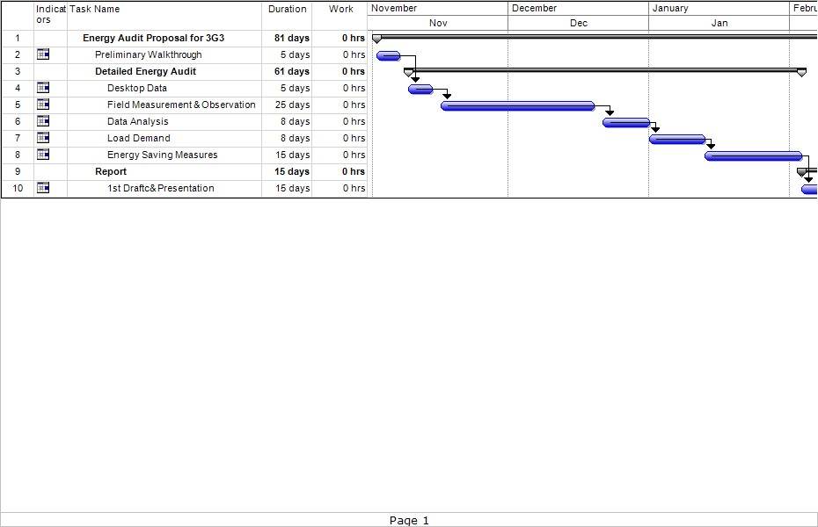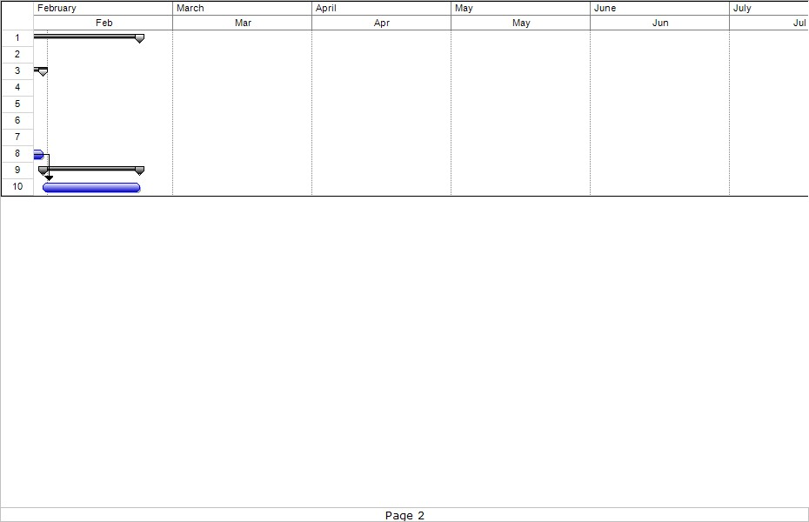

Jan

Feb

Mar

Apr

## ENERGY AUDIT EQUIPMENT

List of equipment

The type of audit equipment is as per table below:

| **Equipment** | **Function** |
| --- | --- |
| http://www.blue-panther.cz/data/files/pel05-725.jpg | **Data Loggers / Power Monitoring Meter (Single/3phase)**  Measures electrical power parameters such as kWh, kVArh, kVAh and power factor (pf)  Other parameters measured include Frequency, Maximum Demand, Voltage, Current and Power Quality  It is normally used to check for electrical faults and if the phases are balanced. |
|  | **Thermohygrometer (Temperature/ Relative Humidity Meter)**  Measures the temperature as well as the relative humidity of an area. It is normally used for air-conditioning design or investigations. Usually measured in °Celsius/°Fahrenheit and %Relative Humidity |
|  | **Anemometer**  Measures the air velocity flowing through a channel. It is normally used for measuring air flow in an air handling unit, at duct intakes and openings such as doorways. Usually measured in m/s. |
|  | **Tachometer**  Measures motor speed on shafts. It is also used to calculate motor efficiency. |
|  | **Ultrasonic Flowmeter**  Measures the velocity of fluid over a known area. It is normally used for measuring chilled water flow in pipes. Usually measured in l/s. |

# MANAGEMENT OF ENERGY

## POLICY AND TARGETS

Policy declaration and brief description of targets and timeframe

*Example*

Client name has an Energy Management Policy in place. The Client is committed to ensuring that all activities in the company are carried out sustainably. Some of the commitments are listed below:

1. Provide adequate training for employees
2. Employ energy conservation and saving practices to all levels of the company
3. Committed to make information on energy conservation and resource available to all levels of the company
4. Committed to comply with local legal requirements where necessary
5. Continuously monitor and control energy consumption
6. Identify energy wastages and take corrective measures to eliminate them
7. Procure energy efficient products
8. Periodically review and improve goals for a successful sustainability program

Targets for the energy management program for Client name are:

1. Real live tracking of energy consumption and maximum demand control
2. Reduce energy cost by 20% within the next 3 years
   * Through implementing energy saving measures
   * Procuring energy efficient equipment
   * Upgrading lighting system and control
   * Training to continuously optimize energy consumption

## ENERGY DATA, DOCUMENTATION AND MONITORING

Describe the level of documentation available in the organization, policies, records, regulations, guides, training in relation to energy management

Describe monitoring of energy use procedures, energy performance indicators, effectiveness of action plans in achieving objectives and targets, evaluation of actual vs expected energy consumption – results from monitoring and measurement should be recorded

*Example*

The energy consumption documents as well as information pertaining to energy consumption such as policy, regulations, procurement documents, design and installation drawings, testing and commissioning reports and financial evaluation reports are kept in the administration office under the purview of the Registered Electrical Energy Manager (REEM), name and is accessible to the top management and energy management team.

The REEM sees to monitoring the energy consumption of the company. Two (2) energy audits have been conducted in the past 8 years and some minor energy saving implementation projects have been carried out, i.e. replacing LED in certain areas and purchasing 5-star appliances for the office.

The REEM also reports the energy consumption to Suruhanjaya Tenaga, Malaysia every 6 months as per requirement.

## COMPLIANCE TOWARDS REGULATIONS

Describe evaluation procedures in complying with legal requirements in relation to energy use and consumption, records

*Example*

The company is subject to EMEER 2008:

1. Is applicable to large energy users, i.e. 300,000kWh consumption for at least 6 months
2. Appointment and notification of Electrical Energy Manager
3. Electrical Energy Management Policy
4. Energy Audit
5. Recommendations for electrical energy management
6. Monitoring and keeping of records
7. Periodical reporting

## ENERGY MANAGEMENT TEAM

List names, position and role

*Example*

The energy management team is headed by Manager name and assisted by his team members as shown in the Chart. The CEO overlooks the whole energy management activities carried out by the company. The team meets once a week to discuss issues pertaining to energy consumption and production output. The activities are mainly carried out by the Engineer and reported back to the energy management team. The Engineer is also a Registered Electrical Energy Manager (REEM).

## ENERGY AUDIT TEAM

List names, position and role

*Example*

The energy audit team is headed by auditor lead and assisted by his team members as shown in the Chart. The Energy Auditor is assisted by a team of experts from various fields of expertise to carry out the various types of energy audit measurements. The data is compiled by the Energy Manager who analysed the data and prepared the energy audit report.

## ENERGY MANAGEMENT MATRIX REVIEW

EM matrix may be used to determine level of energy management practiced and can be used as a guide for improvement

*Example*

An assessment was carried out to determine whether an Energy management system (EnMS) is in place in the building. Currently there is no official system but there have been a few energy saving exercises carried out in the past few years. One such exercise is replacing the car park lighting of 36W bare channel fluorescent lamps with 18W LED lamps. A digital power meter (DPM) is also installed to measure the energy consumption so that savings can be accounted for.

An energy management matrix was used to determine the scope of energy practices being implemented in the building.

|  | **Policy and Systems** | **Organization** | **Motivation** | **Information System.** | **Training and awareness** | **Investment** |
| --- | --- | --- | --- | --- | --- | --- |
| **4** | Formal energy /environmental policy and management system, action plan and regular review with commitment of senior management or part of corporate strategy | Energy / environmental management fully integrated into management structure. Clear delegation of responsibility for energy use | Formal and informal channels of communication regularly exploited by energy / environmental manager and staff at all levels | Comprehensive system sets targets, monitors materials and energy consumption and wastes and emissions, identifies faults, quantifies costs and savings and provides budget tracking | Marketing the value of material and energy efficiency and the performance of energy / environmental management both within the organization and outside it | Positive discrimination in favour of energy / environmental saving schemes with detailed investment appraisal of all new build and plant improvement opportunities |
| **3** | Formal energy / environmental policy but no formal management system and with no active commitment from top management | Energy / environmental manager accountable to energy committee, chaired by a member of the management board | Energy / environmental committee used as main channel together with direct contact with major users | Monitoring and targeting reports for individual premises based on sub-metering / monitoring but savings not reported effectively to users | Programme of staff training, awareness and regular publicity campaigns | Same pay back criteria as for all other investments. Cursory appraisal of new build and plant improvement opportunities |
| **2** | Unadopted / informal energy / environmental policy set by energy / environmental manager or senior departmental manager | Energy / environmental manager in post, reporting to ad-hoc committee but line management and authority unclear | Contact with major users through ad-hoc committee chaired by senior departmental manager | Monitoring and targeting reports based on supply meter / measurement data and invoice. Env / energy staff have ad-hoc involvement in budget setting | Some ad-hoc staff awareness and training | Investment using short term pay back criteria mostly |
| **1** | An unwritten set of guidelines | Energy or environmental management the part-time responsibility of someone with only limited influence or authority | Informal contacts between engineer and a few users | Cost reporting based on invoice data. Engineer compiles reports for internal use within technical department | Informal contacts used to promote energy efficiency and resource conservation | Only low cost measures taken |
| **0** | No explicit policy | No energy environmental manager or any formal delegation of responsibility for env/energy use | No contact with users | No information system. No accounting for materials and energy consumption and waste | No awareness raising of energy efficiency and resource conservation | No investments in increasing environmental performance or energy efficiency in premises |

*To remarks current status of the energy management matrix and target of the building

## OPERATIONS AND MAINTENANCE SYSTEM REVIEW

List scope of works involved for energy management

The Operation & Maintenance Contract for the building covers the following:

* Monitoring and managing energy usage and conservation
* Steps taken and opportunities identified to reduce energy consumption
* Operate a continuous improvement process on energy usage
* Review annually the building performance against current best practice and institute an energy conservation program for the following year
* Demonstrate innovation in the efficient use of energy and materials to provide a sustainable environment
* Conduct energy audits
* Implement energy saving opportunities in stages
* All relevant building energy parameters shall be monitored before and after the energy saving measures are implemented
* An energy saving baseline shall be established for comparison
* Conduct training for awareness to staff
* Integrate best energy practice in the daily operation and servicing of the building

# BUILDING DESCRIPTION

## BUILDING ORIENTATION AND FOOTPRINT

Brief description of the building orientation

*Example*

The building name is located in location. The building stands at 35.34 meters in height with a dome on top of the atrium in the center. The building is 6-storeys high. The building houses general offices, a data centre, library and cafeteria. It currently has around 1,200 occupants. The building has a large atrium in the middle which is air conditioned. There are two levels in the basement for parking. The maintenance office is located in the basement.

The 1st floor comprises of the library, CCTV and BCS room, Cafeteria and a few retail shops. The 2nd to 5th floors consist of general offices. The 6th floor comprises the data centre and rooftop chiller plant.

The Gross Floor Area (GFA), Net Floor Area (NFA) and Air Conditioned Area of the building is given below in the Table. The building office hours are from 8:30 am to 5:30 pm, from Monday to Friday. The occupants do not work on Saturdays.

The building has an East and West orientation with the longest parts of the building facing East and West. This will allow sunlight to enter the building throughout the day causing an increase in heat gain.

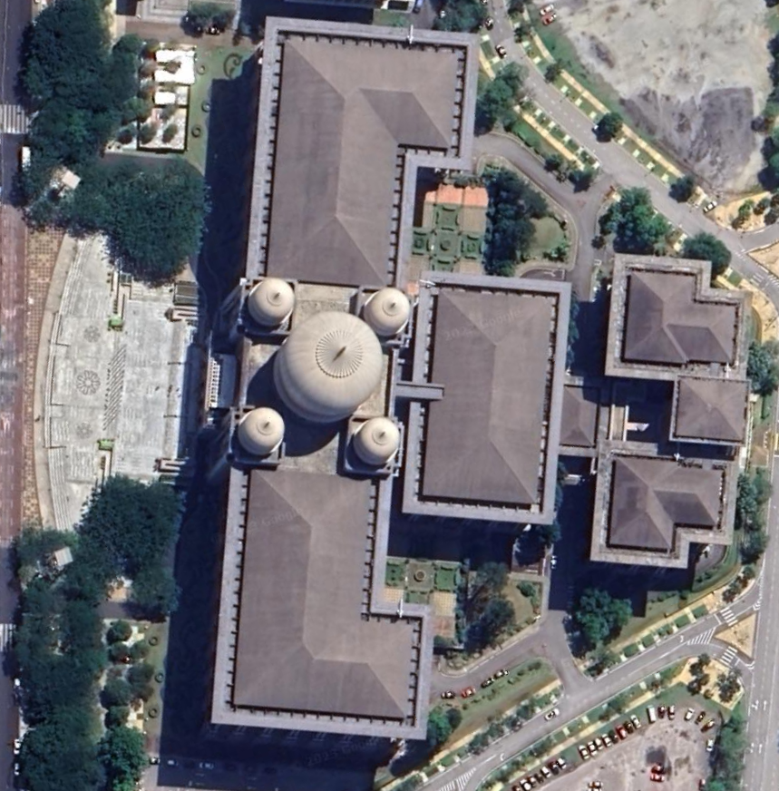

Picture/s of building – side, front, top views

|  |  |  |  |  |
| --- | --- | --- | --- | --- |
| Description | Gross Floor Area | Net Floor Area | Air-Conditioned Area | Height (m) |
| Client name | 83,000 | 62,350 | 45,900 | 35 (6 floors) |

## BUILDING ENVELOPE

*Example*

The OTTV and RTTV criteria, as recommended in MS1525:2019, is used to determine the heat transfer into the building by evaluating the material performance. The thermal performance of the materials is calculated by considering three major conditions of the building which are heat conduction through walls, heat conduction through windows and solar heat gain through windows by radiation. As recommended in the standard, the OTTV of an air conditioned building should not exceed 50 W/m2 and the RTTV not more than 25 W/m2.

### Window

Shading/glazing level

*Example*

Each façade has similar features of shading geometry. Generally, all fenestrations have arches on the 5th level and long pillars at the base of the arches extending all the way down to the 2nd floor.

**sample**

| No. | Description | Thickness (mm) | U-Value (W/m2K) |
| --- | --- | --- | --- |
| 1 | *Fenestration*  Laminated toughened tinted glass | 12 | 4.8 |

### Wall Structure

Type of material, insulation, colour

The building envelope material for building name is shown in the Table. The data for the building material was obtained from the building architectural drawings. The wall material is Granite and there is a layer of asbestos. The colour of the building is mainly light grey with an **α** value of 0.45.

| Material | Thickness (m) | Density kg/m3 | k-value W/m K | Resistance (m2K/W) |
| --- | --- | --- | --- | --- |
| Outside air film | - | **sample** | - | 0.06 |
| Cement Plaster | 0.02 | 1890 | 0.836 | 0.02 |
| Granite Slab | 0.40 | 2640 | 2.927 | 1.17 |
| Asbestos | 0.003 | 720 | 0.108 | 0.03 |
| Cement Plaster | 0.02 | 1890 | 0.836 | 0.02 |
| Inside air film | - |  | - | 0.15 |
| Total Resistance |  |  |  | 1.45 |
| **U-Value** |  |  |  | **0.67** |

### Roof Structure

Type of material, insulation, colour

The material is roof tile with a layer of reflective foil and fibreglass and a layer of asbestos above the ceiling. The colour of the roof is medium grey.

| Material | Thickness (m) | Density kg/m3 | k-value W/m K | Resistance (m2K/W) |
| --- | --- | --- | --- | --- |
| Outside air film | - |  | - | 0.06 |
| Roof Tile | 0.02 | 1890 | 0.836 | 0.02 |
| Reflective Foil & Fibreglass | 0.05 | 32 | 0.035 | 1.43 |
| Asbestos Board | 0.003 | 720 | 0.108 | 0.03 |
| Inside air film |  |  |  | 0.15 |
| Total Resistance |  |  |  | 1.68 |
| **U-Value** |  |  |  | **0.59** |

**sample**

### OTTV/RTTV

The OTTV of the building was calculated using the Window Wall Ratio and U values of the Window and Wall respectively.

Window to Wall Ratio Table

|  |  |  |  |
| --- | --- | --- | --- |
| Wall | Total Glass Area (m2)  **sample** | Total Façade Area (m2) | WWR |
| North West Wall | 1037.18 | 8938.715 | 0.12 |
| North East Wall | 355.6 | 4108.48 | 0.09 |
| South East Wall | 1027.24 | 8938.72 | 0.11 |
| South West Wall | 355.60 | 4108.48 | 0.09 |

The overall window area amounts to only **10%** of the total building façade area.

OTTV Table for each façade and total OTTV

|  |  |  |  |  |
| --- | --- | --- | --- | --- |
| OTTV (North West) | OTTV (North East) | OTTV (South East) | OTTV (South West) | Total OTTV |
| **20.34** | 21.28 | 21.39 | 20.34 | **21.02** |

The building **Total Building OTTV** is calculated to be **21.02 W/m2**.

The detailed calculation is shown in Appendix 1.1. The building can be said to be well insulated from outside heat gain due to the small window area and thick wall construction.

RTTV Table for each roof orientation and total RTTV

**sample**

|  |  |  |
| --- | --- | --- |
|  | Gross Roof Area (m2) | RTTV |
| Flat Roof | 7599 | 108346.1 |
| North East | 1490 | 21244.33 |
| North West | 2857 | 40734.93 |
| South East | 2921 | 41647.44 |
| South West | 1522 | 21700.58 |
| Total RTTV | **16389** | **14.26** |

There is no skylight for this roof structure. The **RTTV** was calculated to be **14.26 W/m2**.

## DAYLIGHTING

Due to the small window area, there is not much opportunity for daylighting into the building.

## NATURAL VENTILATION

The building is air conditioned and there are no openings within the building structure for natural ventilation.

## CEILING (HEIGHT) AND FLOOR – MATERIAL AND COLOUR

The ceiling height for is 7.1m for both the 1st and 2nd floors and 5m for the remaining floors. The inner wall colour is mainly white with the library walls being light yellow.

## LANDSCAPING

The green area surrounds the outer perimeter of the building. There is no greenery or vegetation at the roof levels of within the building. There is a water fountain in the garden just outside the building.

# ELECTRICAL SUPPLY INFORMATION AND ANALYSIS

## TARIFF REVIEW

Describe tariff system used

*Example*

The energy consumption charge is 36.5sen per kWh and maximum demand charge is RM30.30 per kW. The average cost is RM0.43/kWh.

|  |  |  |
| --- | --- | --- |
| Year | Energy Rate (RM/kWh) | Maximum Demand Rate (RM/kW) |
| Jan 2014- present | RM0.365 | RM30.30 |

## MAXIMUM DEMAND REVIEW

Describe maximum demand status and means to control monthly maximum demand levels

*Example*

There is currently no maximum demand control in place.

## VOLTAGE LEVEL

*Example*

The building is supplied by six (6) 3150kVA, 11kV/433V Transformers and three (3) 2.5MVA, 11kV/3.3kV Transformers. In addition, there are three 1.25MVA Standby Generator sets located outside the HT/LV switch room at the ground floor of the building.

## HISTORICAL ENERGY CONSUMPTION

Describe energy consumption and cost

*Example*

The historical energy consumption of the building can be found in the monthly electricity bills for the past 2 years, i.e. 2013 to 2014. Chart below shows the Energy Consumption and Energy Costs for the building from 2013 to 2014.

**sample**

Describe energy consumption, maximum demand and costs

*Example*

The energy consumption is seen at the lowest in the month of July as there were many holidays during that month.

**sample**

## POWER FACTOR

*Example*

There is no power factor penalty.

## Regression Analysis

To do analysis for regression analysis

*Example*

There are there (4) major factors related to Building Energy Index (BEI) determined for building name which are as follows:

1. Independent variable such as (No of working days, no of operations and etc)

Table below shows the data for the independent variable and the dependent variable is operating throughout the month and year in 2023.

|  |  |  |  |  |
| --- | --- | --- | --- | --- |
| **Month 2021** | **Independent variable** | **Independent variable** | **Independent variable** | **Energy Consumptions (kWh)** |
| Jan |  |  |  |  |
| Feb |  |  |  |  |
| Mar |  |  |  |  |
| Apr |  |  | **sample** |  |
| May |  |  |  |  |
| Jun |  |  |  |  |
| Jul |  |  |  |  |
| Aug |  |  |  |  |
| Sep |  |  |  |  |
| Oct |  |  |  |  |
| Nov |  |  |  |  |
| Dec |  |  |  |  |

Table 5: xxx

To do analysis for single and multiple regression

**Multiple Analysis using Three (3) Variable Factors**

Multiple Regression Analysis was performed using Microsoft Excel for number of patients, number of working days as the multiple independent variables. Table below shows the summary of output of the Regression Analysis. From Table, the y-intercept, the coefficient of each independent variable as in Equation 1, R-square (coefficient of determination) and standard error of the mathematical modelling can be obtained.



**sample**

**Table 5: Regression with Three Independent Variables**

**Y = 47.57x1 + 18439.21x2 +209.85x3 + 4938.49**

Where,

Y = Electricity consumption (kWh)

X1 = independent Variable

X2 = independent Variable

X3 = independent Variable

4938.49 = Base load

The R2 = 0.833 is more than 0.75. All these 3 factors will be considered in monitoring the energy consumption

# ENERGY CONSUMPTION INFORMATION AND ANALYSIS

## ELECTRICITY SUPPLY

### SYSTEM DESCRIPTION

Describe system

*Example*

The building has two 11kV/415V TNB Incomers supplying power to the building. The building electrical supply and distribution system then feeds into two transformers Tx1 and Tx2. Both transformers are rated at 2500kVA/3500kVA. The transformers feed 2 MSBs labelled MSB1 and MSB2 respectively. The Annex building also obtains its power supply from the main building MSBs.

Two (2) 1250kVA Gensets are used for back-up supply in case of power failure. The two gensets are on standby during power failure.

**sample**

### BUILDING LOAD PROFILE ANALYSIS

Describe load profile

For systems with more than 1 MSB, please total up the total MSB loads for the total building load profile

*Example*

Data Loggers to measure power in an hourly profile were installed in both MSBs. The loggers recorded the voltages, average frequency and power factor for the 3 phases. The electrical load profiles were recorded on a daily and weekly basis. Both weekday and weekend profiles were captured and monitored. The total load profile is shown in the following graph. Appendix 2 shows the graphs for the 2 weeks measured weekday and weekend profiles.

**sample**

### OBSERVATION AND FINDINGS

During the audit, the energy audit team identified air conditioning equipment running for 24hours. The weekday load profile shows that there is a baseload of approximately 622kW running during off peak hours. The daily peak load starts at 6:30 am and increases to full load of 1090kW from 8:00 am onwards. It starts decreasing from 4:30 pm until 6:00 pm.

The baseload is 622kW which is very high. The ‘baseload’ is defined as the minimum amount of power used by the building during off-peak operation hours including weekends. Baseloads include equipment that consume energy throughout the day such as ICT equipment such as servers, modems, hubs and switches, air conditioning for ICT rooms and general equipment such as refrigerators, fax machines, CCTV, security and access systems, compound or car park (basement levels) lighting, etc.

## CHILLED WATER SYSTEM AND DISTRIBUTION

### SYSTEM DESCRIPTION

Describe system

*Example*

The air conditioning system in the building is supplied by a number of air handling units in several plantrooms around the building, which serve manufacturing area, offices, canteen and certain parts of general area of the building. The air conditioning system components include:

* Six (6) water-cooled chillers, cooling towers, chilled water pumps and condenser water pumps located at the air conditioning plant, outside the manufacturing block.
* Forty (40) air handling units (AHUs) located in the building AHU plant rooms on each floor
* Three Hundred and Eighty-Six (386) fan coil units (FCUs)
* Twelve (12) package air conditioners (PAUs).

The air conditioning for the plant is run for 24 hours a day.



**sample**

### LOAD PROFILE ANALYSIS

Describe load profile

*Example*

The chilled water is on a continuous 24-hour supply to the building. This chilled water is metered with a Calorimeter, which is sited in the Chilled Water Pump room.

Ultrasonic Flow Rate Meters were used to measure:

* 24 hours supply and return chilled water temperature
* 24 hours chilled water flow rate

These measurements were for a 1-week time period.

* Electricity power to the pumps
* Electricity frequency to the pumps

These measurements were taken with the instruments listed below.

|  |  |
| --- | --- |
| Equipment | Purpose |
| Temperature Logger and Probe | To measure temperature and time |
| Ultrasonic Flow Rate Meter | To measure flow rate |
| Multimeter | To measure amperes |

Using the above temperature logger and probe together with the ultrasonic flow meter, the 24 hours chilled water supply was measured for its supply and return temperatures and its flow rates.

The daily 24hour temperature and flow rate data is used to confirm the:

* Average supply and return chilled water temperature
* Average temperature differential (∆T)

Profiling the flow rate of the supply and return chilled water

**sample**

**sample**

### OBSERVATION AND FINDINGS

Evaluate Chiller COP and System COP

*Example*

From the chiller plant energy audit works, it can be concluded as the following;

A week data measurement of chiller plant shows that COP of chiller No 1 is 4.7 and COP of chiller No 2 is 4.5. Based on the System COP chart below, the chillers are considered to still be within ‘Good’ range.

Average chiller COP

Chiller No 1: 4.7

Chiller No 2: 4.5

Chiller No 3: 4.2

Average leaving chilled water temperature for all chillers are also high (9.6oC & 9.5oC respectively for chiller 1 & 2). This indicates inability of both chillers to produce chilled water temperature at set point (7.0oC). Leaving condenser water temperatures are also at the high side, 37oC against chiller rated condenser leaving temperature of 35oC.

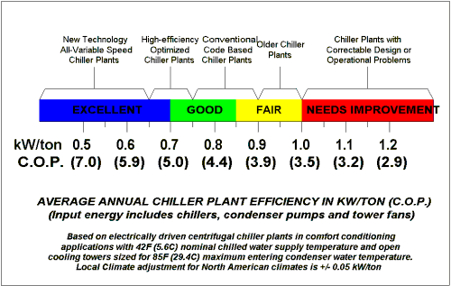

## AIR CONDITIONING AND MECHANICAL VENTILATION SYSTEM

### SYSTEM DESCRIPTION

Describe system

*Example*

The air conditioning system in the building is supplied by a number of air handling units in several plantrooms around the building, which serve manufacturing area, offices, canteen and certain parts of general area of the building. The air conditioning system components include:

* Six (6) water-cooled chillers, cooling towers, chilled water pumps and condenser water pumps located at the air conditioning plant, outside the manufacturing block.
* Forty (40) air handling units (AHUs) located in the building AHU plant rooms on each floor
* Three Hundred and Eighty-Six (386) fan coil units (FCUs)
* Twelve (12) package air conditioners (PAUs).

The air conditioning for the plant is run for 24 hours a day.



**sample**

### BLOWER FAN SPECIFIC POWER

Describe findings

*Example*

The fan specific power is a measure of the air distribution system efficacy in W/m3.hr. It is the ratio of power consumed in Watt to the delivered air flow in cubic meter per hour. MS1525:2019 standard recommends that the power required by the entire fan system at design condition (for air flow >17,000 m3/hr) should not exceed 0.42 W/m3.h for AHU with operation time exceeding 750 hours a year.

The air flow data of twelve (12) AHUs have been obtained and compared with the MS 1525:2019. None of the AHUs with more than 17,000 m3/hr (10,000 cfm) air flowrate were found to be operating below the recommendation design value of 0.42 W/m3.hr. Table below shows the AHU air flow statistics data.

| No | AHU | Air Flow Rate, m3/hr  **sample** | | Fan Power, W | Fan Efficiency, W/m3hr |
| --- | --- | --- | --- | --- | --- |
| Design | Running |
| 1 | AHU-L1-MO1.4 | 28,237 | 17,193 | 8,668 | 0.50 |
| 2 | AHU-L1-MO1.8 | 34,503 | 33,361 | 9,833 | 0.29 |
| 3 | AHU-L1-MO1.9 | 24,451 | 9,539 | 7,439 | 0.78 |
| 4 | AHU-L2-MO1.1 | 37,392 | 25,554 | 9,768 | 0.38 |

### AIR CHANGE RATE AND AHU CAPACITY ANALYSIS

**sample**

Describe findings

The air change analysis was carried out to determine the actual air change rate for all zones. The air change rate is based on how many times the air within a defined space is replaced in an hour.

Table below provides the calculated values of Air Change per Hour (ACR). Majority of the AHU has low ACH except for AHU PR 1/6 which serves OT room (designed minimum ACR of 20). Minimum ACR is generally 6.0 ACH to prevent fungus growth. No major energy saving potential can be realized from ACR reduction.

| No | AHU | Capacity, Btu/hr | Air Flow Rate, m3/hr | | Served Area, m2 | Air Change Per Hour (ACH) | | Capacity Intensity, Btu/hr ft2 |
| --- | --- | --- | --- | --- | --- | --- | --- | --- |
| Design | Running | Design | Running |
| 1 | AHU-L1-M01.9 | 593,688 | 25,269 | 9,539 | 969.2 | 8.5 | 3.2 | 56.9 |
| 2 | AHU-L1-M01.8 | 812,056 | 34,503 | 33,361 | 1,600.9 | 7.0 | 6.8 | 47.1 |
| 3 | AHU-L1-M01.4 | 665,340 | 28,252 | 17,192 | 1,077.5 | 8.6 | 5.2 | 57.4 |
| 4 | AHU-ANX-L1A.3 | 535,684 | 22,824 | 5,853 | 925.2 | 8.1 | 2.1 | 53.8 |

### INDOOR AIR QUALITY

Describe findings

*Example*

The measurement for indoor air quality is done using a CO2 sensor. In most buildings CO2 sensors are installed in the return duct of the air conditioning system. The indoor air quality measured in the building is within the range of 158 and 381ppm. The maximum allowable reading in a room is 1000ppm after which the air in the room will become stale and will make the occupants feel sleepy due to lack of oxygen and fresh air.

**sample**

### TEMPERATURE AND RELATIVE HUMIDITY

Describe findings

*Example*

The temperature and relative humidity levels for each space were measured using temperature logger at selected area to represent the level of cooling and moisture content of the workspace. The minimum temperature is 19.3C and relative humidity levels are 50% and 85% respectively. Some areas are too cold and the temperature setting in these areas need to be increased. This could be due to failed control functionality of the VAV boxes or faulty temperature/RH sensors.

The measured RH of more than 70%, i.e. high moisture content in the air can lead to mould growth between cold and warm spaces such as door/window openings.

**sample**

**sample**

### OBSERVATION AND FINDINGS

From the air conditioning and ventilation energy audit works, it can be concluded as the following:

1. The condition of the AHU plantroom needs to be improved as some plantroom 4 was found to be very dusty. This may cause the filters to get dirty very fast and load the AHU blower fan. Maintenance is done periodically.
2. It was noted that condensation was seen in a few parts along the ducting. Source of the leakage or problem should be rectified immediately in order to reduce energy losses through loss of cooling.
3. The need to compensate the centralized cooling with ACSU, shows that there is insufficient cooling provided by the centralized cooling system and the system needs to be reviewed.
4. All air conditioning areas have automatic door closers and doors are always kept closed.
5. The room temperatures are sufficient at time of audit but there have been complaints that it gets too warm when there are many people in the waiting area.

## LIGHTING SYSTEM

### SYSTEM DESCRIPTION

The different types of lighting equipment and quantity is listed in the table below.

| Picture | Lamp Type | Lamp (W) | Ballast (W) | Qty | Area Used |
| --- | --- | --- | --- | --- | --- |
| http://www.lalighting.com/wp-content/uploads/2013/04/FPA2X4.jpg | 2 x 4 recessed with full reflectors | 36 | 8 | 350 | Office, Laboratory |
| http://www.akitasmexico.com/wp-content/uploads/2014/08/kitchen-fluorescent-light-fixtures.jpg | 1 x 4 recessed with prismatic diffuser | 36 | 8 | 3350 | Staircase, Corridors |
| http://www.hatoshop.eu/media/catalog/product/cache/1/image/9df78eab33525d08d6e5fb8d27136e95/t/l/tlo_1.jpg | 1 x 4 bare channel | 36 | 8 | 300 | Car park |
| http://www.lightingandmaintenancesolutions.com/wp-content/uploads/2013/12/CFL-Bulb.jpg | CFL  **sample** | 18 | - | 60 | Lobby, Lifts |
| http://www.seewide.com.my/webshaper/pcm/pictures/Products/philips-par38-120c-sp_large.jpg | PAR | 60 | - | 15 | Rooftop |
| http://protechelectrical.com.fj/products/Colored-Incandescent-Bulb.jpg | Incandescent | 100 |  | 80 | Decorative lighting for Foyer, Building Façade |
| http://safamedical.com/images/medicalfurniture/examination/3079.jpg | PAR | 60 |  | 80 | Tasklight |

The lighting operating schedule of the building is listed below in the table.

**sample**

| No | Description | Operation Hours | |
| --- | --- | --- | --- |
| Start | Stop |
| Main Building | | | |
| 1 | Office | 7:30am | 17:30pm |
| 2 | Lobby, Walkways | 7:00pm | 18:30pm |
| 3 | Car park | 7:00pm | 7:00am |

### LUX LEVEL

Describe findings

*Example*

The lux levels for each space was measured using a lux meter to indicate the level of lighting the occupants receive in the workspace. The average lighting levels in the office space is 240 lux. The maximum lighting level recorded is 1052 lux in one of the offices which is more than sufficient than the recommended values stipulated in the MS1525:2019, standard. The average lux levels in the common walkways and lobby is 175. See Appendix 5 for the room lux level readings.

The car park lighting was upgraded from 36W fluorescent tubes to 18W LED tubes. There is a separate report on the installation with the Facility Manager. The car park lighting is switched on 24 hours. There is sufficient lighting in the car park for some areas that are compensated with daylight due to openings within the car park area. See Figure 11.

**sample**

### OBSERVATION AND FINDINGS

From the lighting energy audit works, it can be concluded as the following:

1. The number of lights can be reduced for the over lit areas.
2. Car park lighting can be switched off during the day when there is sufficient daylight in the areas closest to the sides of the building openings.

## VERTICAL TRANSPORT SYSTEM

### SYSTEM DESCRIPTION

Briefly describe lift system

*Example*

The lift system used is a conventional traction system that use ropes that pass over a wheel connected to an electric motor. The motor is controlled using an electronic drive.

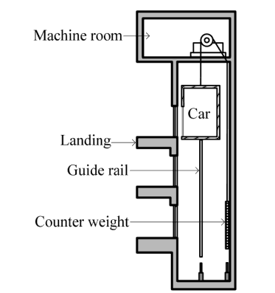

### LIFT/ESCALATOR USAGE ANALYSIS

Describe system and operation

*Example*

The list of lifts is shown in the table below. All lifts operate from 6:30 am to 7:00pm daily, except the OKT and service lift which operates 24 hours daily.

|  |  |  |  |
| --- | --- | --- | --- |
| Room No./ Description | Equipment Description  **sample** | Rated Power [kW] | Quantity |
| North Lift | Lift No. 2 | 22 | 1 |
| South Lift | Lift No. 4 | 22 | 1 |
| Main Lobby | Lift No. 6 | 22 | 1 |
| Main Lobby | Lift No. 7 | 22 | 1 |
| OKT Lift | Lift No. 8 | 11 | 1 |
| Service Lift | Lift No. 12 | 22 | 1 |

### OBSERVATION AND FINDINGS

Lift operating hours can be reduced. The lift motors are standard motors.

## PLUG LOADS

### PLUG LOADS USAGE ANALYSIS

Describe findings

*Example*

The equipment used in the building includes general office equipment comprising, PCs, mainframe computers, printers, binders, cutters, audio-video equipment, projectors and other low power equipment.

### OBSERVATION AND FINDINGS

*Example*

During the energy audit, it was noticed that some computers were left running during the lunch break. There have been instances where computers are left running overnight according to the security guards.

## BUILDING MANAGEMENT SYSTEM

### SYSTEM DESCRIPTION

Describe findings

Figure below shows a typical schematic of the building control system. Control of the equipment can be done via the BCS such as start/stop functions of Pumps, AHU, FCU, VRV, Fans and Lights. Further control can be done to set VSDs and VAV dampers to open/close to the required setpoint. Feedback from sensors such as temperature, humidity and CO2 can also influence the VSDs and VAVs to operate to the required setting.

**sample**

|  |  |  |
| --- | --- | --- |
| System | Equipment | Control strategy |
| ACMV | AHU | * Fan speed is controlled by variable speed drive. Controlled variable is supply duct static pressure which is set at certain value. * Control valve position is controlled by valve actuator. Controlled variable is supply air temperature. * AHU operation is controlled by schedule program from BCS. |
|  | VAV | * VAV damper position is controlled by VAV actuator. Controlled variable is zone temperature. * VAV position and zone temperature are monitored by BCS. |
|  | VRV | * VRV damper position is controlled by VAV actuator. Controlled variable is zone temperature. * VRV position and zone temperature are monitored by BCS. |
|  | Ventilation/Fresh Air Fan | * Fresh air fan operation hours are controlled by schedule program from BCS. * Speed regulation of fresh air fan is controlled by Variable speed drive. Controlled variable is static pressure which varies according to fresh air damper position to each AHU. |
|  | Chilled water pump | Chilled water pump is controlled by variable speed drive. Controlled variable is chilled water pressure differential between supply and return main. |
| Lighting | Indoor General Areas | Lighting operation is controlled by schedule program from BCS |

### OBSERVATION AND FINDINGS

*Example*

The facility manager/maintenance team/BCS operator are currently implementing upgrade works on the various equipment, communication links via sensors and controls and rescheduling of operation times for individual equipment. Testing and commissioning works are also being carried out to test the response of each equipment.

# LOAD APPORTIONING AND ENERGY INDICES

### LOAD APPORTIONING

Describe load apportioning breakdown

*Example*

The air-conditioning load for the building name building comprises of about **76%** of the total building load. The lighting and general equipment comprise **12%** and **4%** respectively of the total building load.

|  |  |  |
| --- | --- | --- |
| **End Use Loads** | **Annual Consumption (kWh)**  **sample** | **Percentage** |
| Cooling Energy | 2,281,310.00 | 28% |
| Lighting | 979987.57 | 12% |
| General Plug Load | 359049.33 | 4% |
| Chilled Water Pumps | 281756.64 | 3% |
| AHU | 2389722.14 | 30% |
| FCU and ACCU | 556365.12 | 7% |
| Ventilation Fans | 474451.85 | 6% |
| Rooftop Chiller | 118081.65 | 1% |
| VRV | 607505.74 | 8% |
| Lift | 12776.99 | 0.2% |

**sample**

### ENERGY INDICES

The following are the energy and power indices obtained from the energy audit.

|  |  |  |
| --- | --- | --- |
| **Energy Intensity Index** | **sample** |  |
| Building Energy Intensity Index (BEII) |  | kWh/m2 |
| Lighting Energy Intensity Index (LEII) |  | kWh/m2 |
| Air Conditioning Energy Intensity Index (ACEII) |  | kWh/m2 |
| Building Power Baseload |  | kW |

|  |  |  |
| --- | --- | --- |
| **Power Density Index** |  |  |
| Lighting Power Density |  | W/m2 |
| Air Conditioning Power Density |  | W/m2 |
| Equipment Power Density |  | W/m2 |
| Baseload Power Index |  | W/m2 |

# ENERGY SAVING MEASURES AND FINANCIAL EVALUATION

**ESM No.1**

*It was found that…*

Describe the problem

*It is recommended that…*

Describe the solution

*Show the method of calculation and assumptions made:*

Include:

* Energy consumption before
* Energy consumption after
* Cost savings in RM
* Estimated Investment costs in RM
* Simple Payback Period/Return on Investment
* Percentage saving compared with overall energy consumption baseline

*Example*

Reduce the outside air infiltration to the building through the external & internal doors and windows. Excessive outside air (OA) infiltration causes an increase in the running cost of the air-conditioning system. It is estimated that the level of OA (Leak and intake from AHU) into the building is 101,287 l/s. Fixing the leakage from badly fitted outside doors, leaks at the windows, installing automatic door shutters for the outside opening at the front of the building, repair air curtain, reducing uncontrolled infiltration through the corridor within the building, lobby areas and other areas can reduce the outside air infiltration to 50,644 l/s (reduce 50% of OA).

Installing automatic door shutter – RM3,000

Repair air curtain – RM12,000

Reducing uncontrolled infiltration – RM25,000

This can reduce the building energy consumption by **975,725 kWh** with a monetary value of **RM 263,446**. The total estimated budget cost of implementing these measures is **RM 40,000** offering a **0.15 years (less than 2 months) payback period**.

Describe the step to implement ESM

### SUMMARY OF ENERGY SAVING MEASURES

*Example*

Seven (7) Energy Saving Measures (ESMs) have been identified in the Energy Audit conducted. By implementing all recommended Energy Saving Measures, the energy consumption for Building name can be reduced by about **23%**, or **52,416kWh** per year representing **RM15,096** in monetary value. The estimated budget cost of implementing the Energy Saving Measures is **RM27,042** with a payback period of about **1.79 years**. The estimated savings, budget costs and Simple Payback Period of all recommended Energy Saving Measures, are listed in the table below.



**sample**

# ENERGY SAVING MEASURES IMPLEMENTATION PLAN (3 YEARS)

Describe method statement/action plan to carry out implementation

The table below lists the implementation measures to be carried out over the course of 3 years.

|  |  |  |  |  |
| --- | --- | --- | --- | --- |
| **Year** | **Measures** | **Percentage Reduced** | **Cost in RM** | **Time to Implement** |
| **Base year** |  |  |  |  |
| **Year 1** | **No Cost** | **5%** |  |  |
| ESM 1 |  |  |  | 1 month |
| ESM 2 |  |  |  | 3 months |
| **Year 2** | **Low/Medium Cost** | **7%** |  |  |
| ESM 3 |  |  | **sample** | 5 months |
| **Year 3** | **High Cost** | **8%** |  |  |
| ESM 4 |  |  |  | 2 months |

**Method statement**

*Example*

ESM 1 – Replace existing lighting to LED

1. Conduct an energy audit to measure current consumption
2. Remove and replace existing lighting lamps/fixtures
3. Install new lighting/fixtures
4. Install energy meter for measurement and verification of new energy consumption

# CONCLUSION

Describe BEI Chart

*Example*

Using the estimated current annual energy consumption **232,050kWh** and occupied areas, the current Building Energy Index (BEI) is **274 kWh/m2/year** costing **RM67.68/m2/year** and after implementing all recommended Energy Saving Measures to **163 kWh/m2/year** costing **RM52.13/m2/year.** The percentage reduction is **41%.**

**41% Reduction**

Describe number of diamonds achieved based on percentage reduction of BEI



Based on the SEDA Sustainable Energy Low Carbon Building Assessment GreenPASS by Construction Industry Standard 2012 CIS20, the level of achivement in xx % carbon reduction is eligible for xx diamond certification. All the information can get from the SEDA website.

https:/www.seda.gov.my/greenpass

# VERIFICATION

|  |  |  |  |  |
| --- | --- | --- | --- | --- |
|  | | This Energy Audit Report is: | | |
| prepared by: | checked by: | | received by SEDA Malaysia | received by SEDA Malaysia |
|  | **sample** | |  |  |
| Name:  Position:  Date: | Name:  Position:  Date: | | Name:  Position:  Date: | Name:  Position:  Date: |